MEMO |  |  |  |  | 
To: | Hunter and Central Coast Regional Planning Panel
From: | Amy Regado, Section Manager Development
File: | DA/2237/2017 | Reference: | PPSHCC-35 | Date: | 18 September 2022
Subject: | Supplementary information for Catherine Hill Bay residential subdivision
Following the submission of the supplementary assessment report on 14 November 2022, the Hunter and Central Coast Regional Planning Panel (Panel) requested Council staff provide a memo to the Panel addressing the following:
- Overview of plans submitted to support supplementary assessment report
- Flowers Drive interface
- Conservation land subdivision and minimum lot size
This memo responds to this request.
Plans provided to support supplementary assessment report
The following table outlines the plans provided to support supplementary assessment report, and changes made from previous versions.
Plan reference on Portal | Plan name | Changes from previous plans
Appendix K - Plan of Proposed Subdivision (November 2022) - DA22382017 - 1A Flowers Drive Catherine Hill Bay_PPSHCC-35 | Plan of Proposed Subdivision of Lots 1 & 2 DP 1180181 (rev 9) | Change of location and width of drainage easement along APZ line of lots in Hamlet A adjacent to Flowers Drive.  Easement is no longer located in vegetation buffer/APZ.  Better naming and lot numbering of reserves to be dedicated to Council in accordance with submitted land dedication plan.
Land Dedication Plan (November 2022) - DA22382017 - 1A Flowers Drive Catherine Hill Bay_PPSHCC-35 | Plan of Areas of Dedication to Council Lots 1 & 2 DP 1180181 (Rev 2) | New plan  Clearly shows proposed roads, reserves, drainage reserves, and road widening to be dedicated to Council.  Includes dimensions of Flowers Drive road widening.
Appendix AR - Arboricultural Impact Evaluation Report November 2022 - DA22382017 - 1A Flowers Drive Catherine Hill Bay_PPSHCC-35 | Arboricultural Impact Evaluation Report (dated 4/11/22) | Change reference to updated landscape and engineering plans.
Appendix AY - Hamlet A Engineering Concept Design Plans Rev 5 November 2022 - DA2232017 - 1A Flowers Drive Catherine Hill Bay_PPSHCC-35 | Hamlet A Engineering Concept Design Plans (Rev 5) | Relocation of IAD line from parallel to Flowers Drive, to east of APZ (outside of vegetation buffer).
Appendix AZ - Hamlet B Engineering Concept Design Plans Rev 5 November 2022 - DA22382017 - 1A Flowers Drive Catherine Hill Bay_PPSHCC-35 | Hamlet B Engineering Concept Design Plans (Rev 5) | Inclusion of cross sections of Roads 6 and 7 (perimeter roads) to ensure consistency for retaining wall offset and swale locations.
Appendix BC - Hamlet B Containment Cell Plans November 2022 - DA22382017 - 1A Flowers Drive Catherine Hill Bay_PPSHCC-35 | Hamlet B Containment Cell Plans (rev 4) | Demonstrates location of environmental contamination proposed to be placed at 2-5m below ground surface as per RAP.
Appendix N - Landscape Plans Rev Q_November 2022 - DA22382017 - 1A Flowers Drive Catherine Hill Bay_PPSHCC-35 | Landscape Plans (Rev Q) | Inclusion of dimensioning of Flowers Drive buffer zone, and perimeter cross sections consistent with amended engineering cross sections.

Flowers Drive interface
The construction access arrangements for the development will be via the existing dwelling house accesses to Hamlet B and Colliery Road (Hamlet B), as identified in Figure 1.
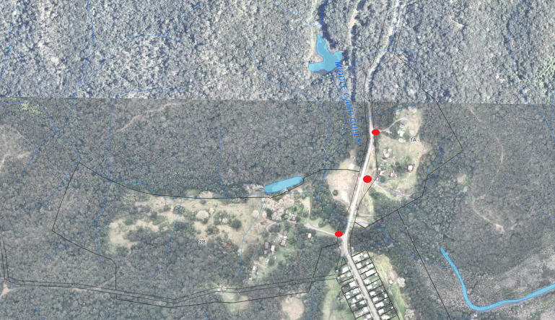
Figure 1: Location of existing successes to site
Figure 2 and Figure 3 demonstrate the road reserve, pavement width, and how the 10 metre landscape buffer within the road reserve is achieved. The images demonstrate:
- The road reserve (shown in green) is generally 20 metres wide, inclusive of proposed road widening (shown in yellow)
- The existing Flowers Drive pavement is 6 metres wide (shown in grey)
- The landscape buffer achieves minimum 10 metres from Flowers Drive pavement (shown dotted green line) to private lot boundary (dotted blue line)
Fencing will be located to the rear boundary of private lots and is shown in dotted blue on the images below. Draft condition 28 specifies fencing to be metal palisade or slatted fence 1.8m high and of dark natural (or black) in colour. Figure 4 and Figure 5 demonstrates fencing outcomes that would be consistent with the condition.
Note, the application does not include footpath along Flowers Drive.
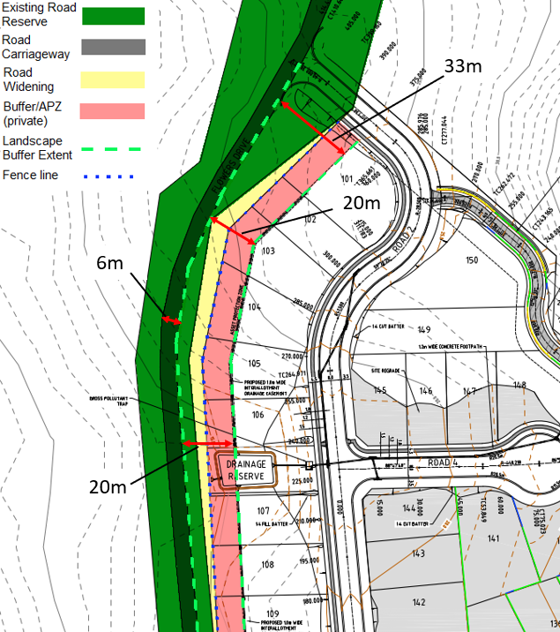
Figure 2: Flowers Drive interface outcome - northern section
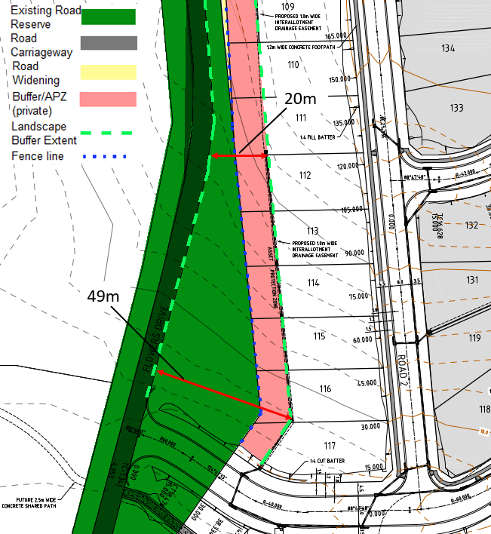
Figure 3: Flowers Drive interface outcome - southern section
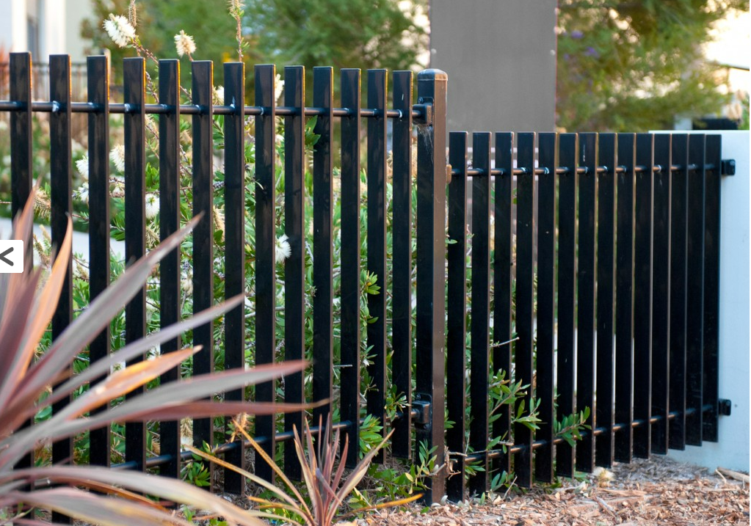
Figure 4: Proposed fencing types – vertical
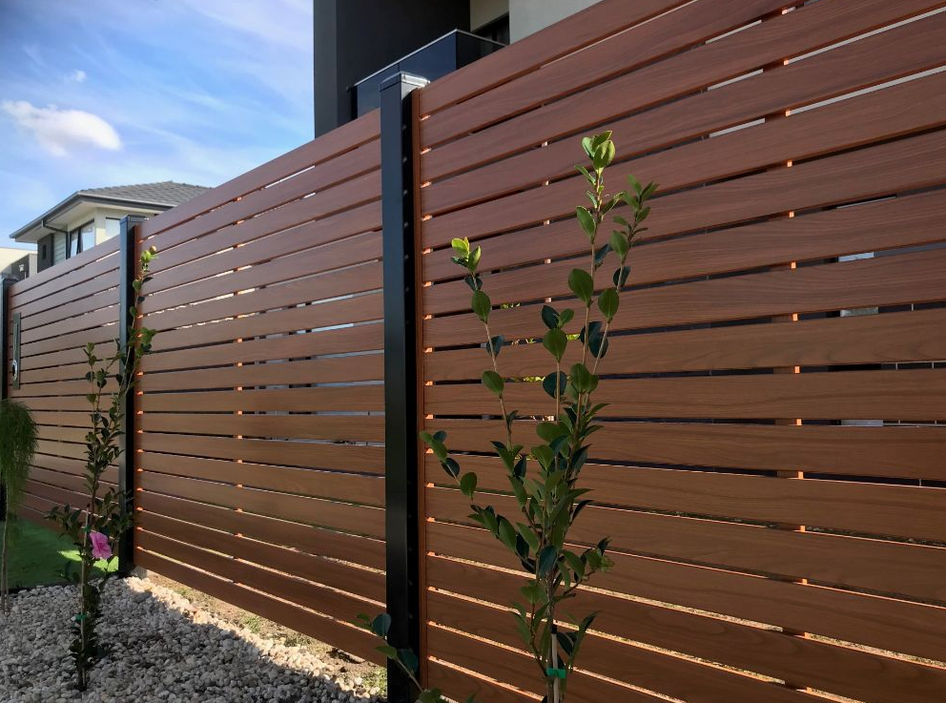
Figure 5: Proposed fencing types – horizontal
Conservation land subdivision and minimum lot size
Further to Section 9 of the supplementary assessment report (November 2022), the subdivision of lots 152, 153, 246, and 247 located within the C2 zone is permitted as exempt development under Subdivision 38 of the State Environmental Planning Policy (Exempt and Complying Development Codes) 2008.
The SEPP permits the subdivision of land for the purpose of creating a public reserve (including drainage reserves), and no minimum lot size applies.
Whilst the lots do not achieve the prescribed minimum lot size in the C2 zone (being 100ha, and only have areas between 1641m²-2.047ha), the proposed subdivision is permitted as outlined above.

Should you have any further questions, or require further information to assist in the Panel’s determination of the application, please contact me on 0430 222 469 or aregado@lakemac.nsw.gov.au.

Amy Regado
Section Manager Development
Development Assessment and Certification

